**USE CASE: SET APP CONFIGURATION: (MAIN SUCCESS SCENARIO AND SSD):**

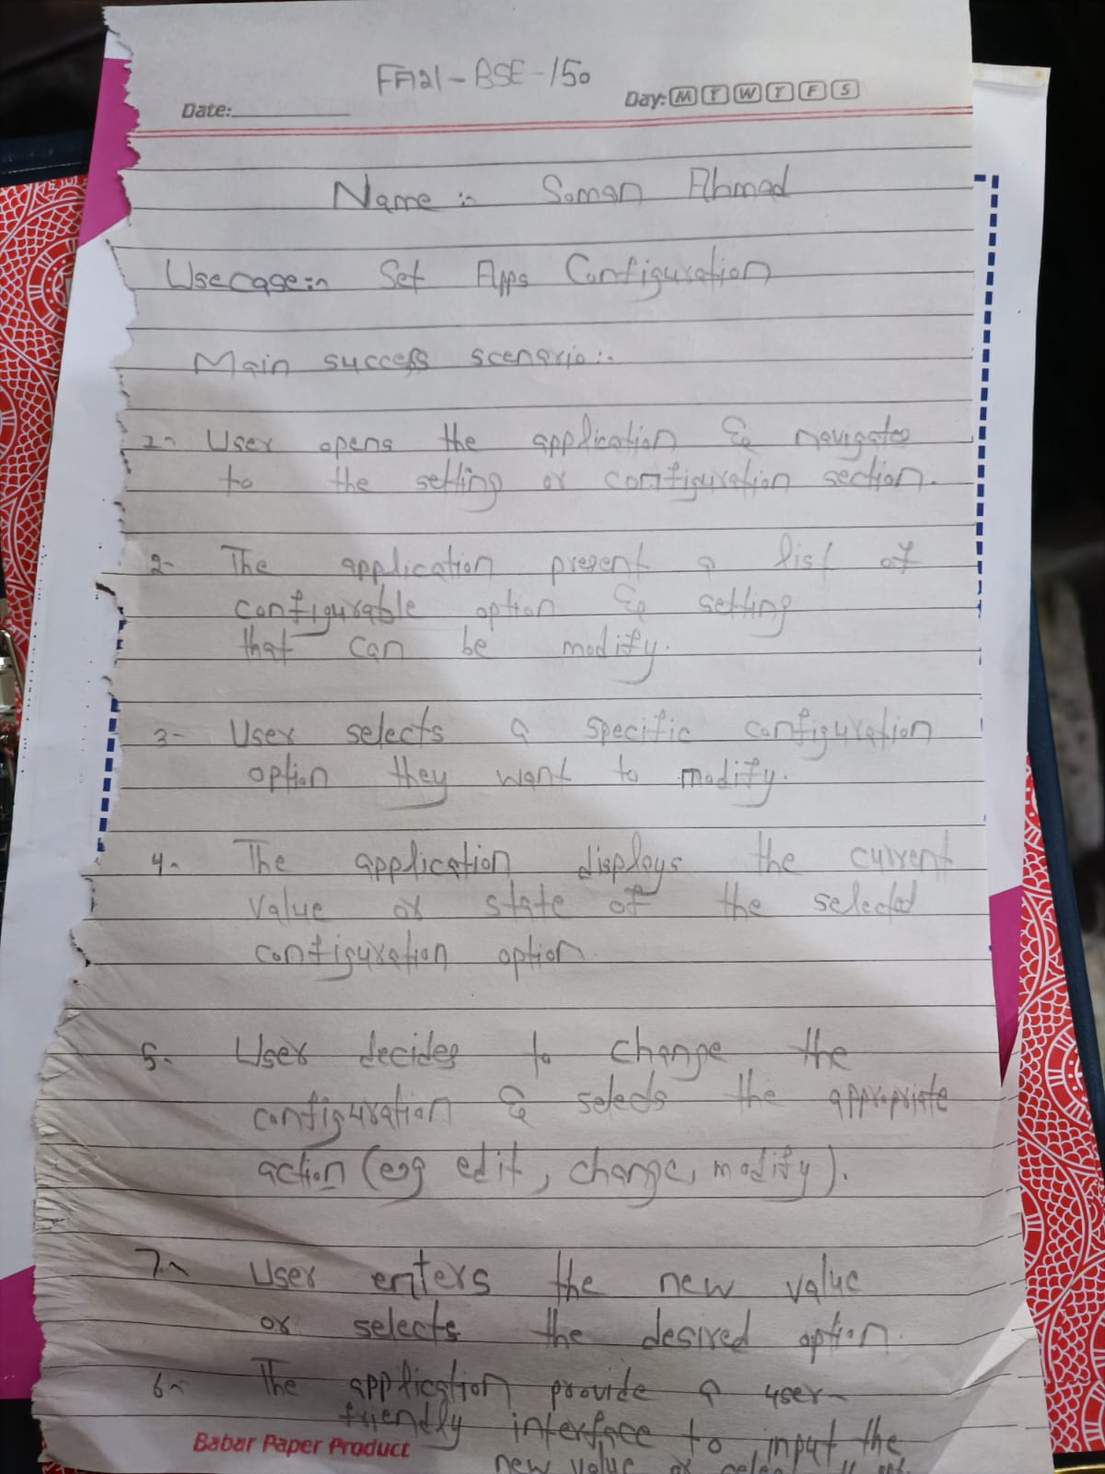

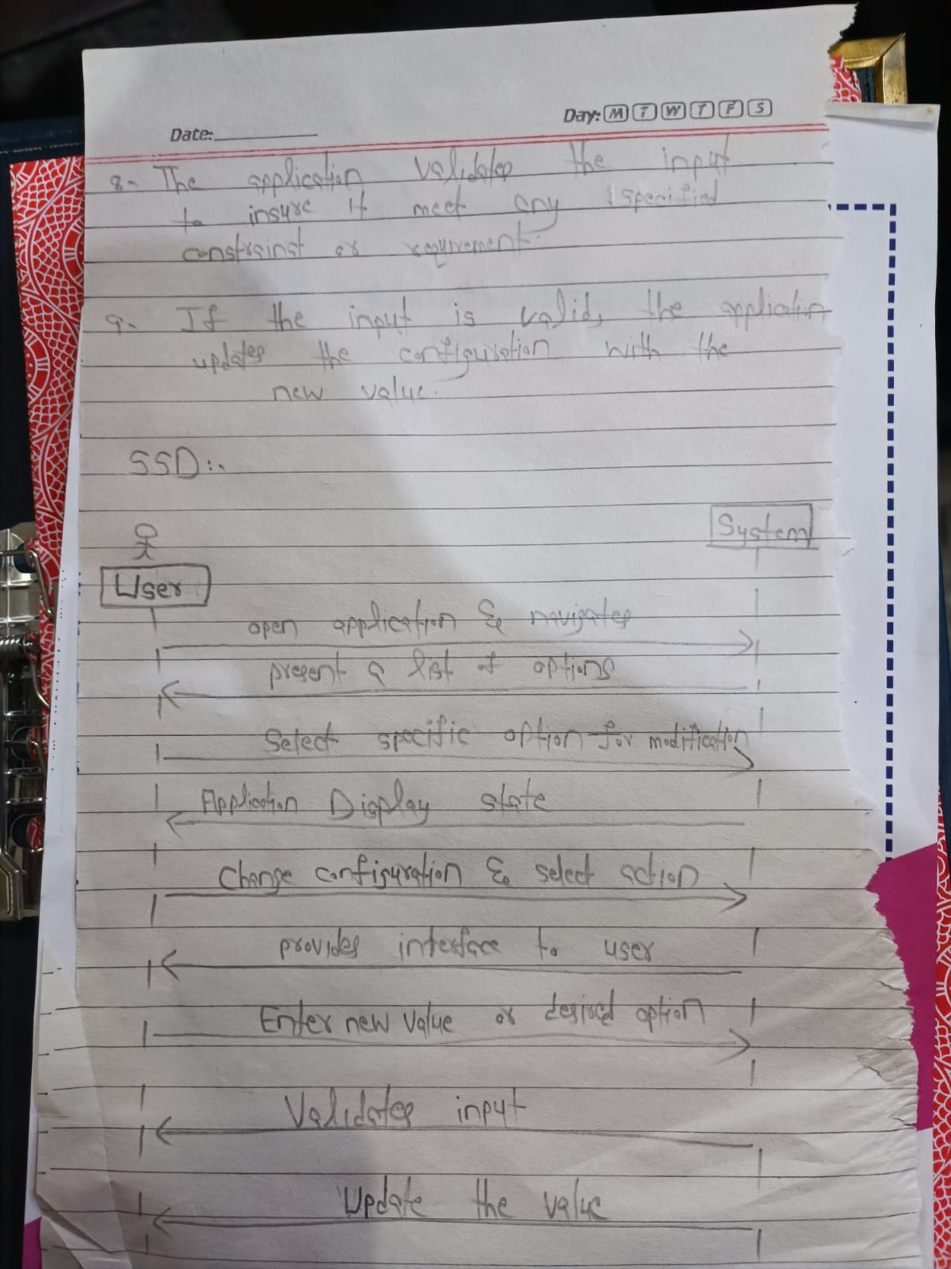

**STAR UML:**

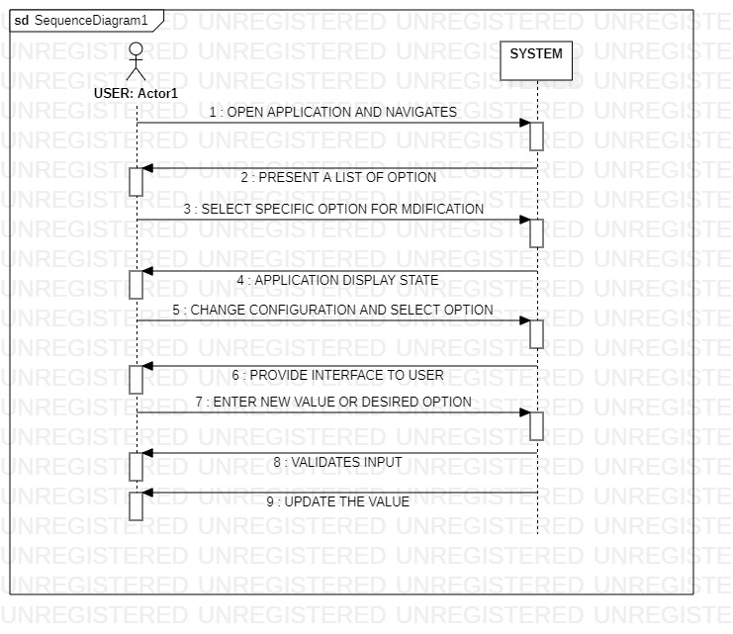

**PROTOTYPE:**

